User Guide – SpectralHost

1.0 Introduction
SpectralHost is a windows based application to work with Spectrophotometer using PC
through RS 232 port. SpectralHost allows user to operate Instrument from PC, import
results from instrument, store results in PC data files and perform analysis on the stored results.

2.0 How to Start?
Install SpectralHost from the CD. It is recommended that “Readme.txt” should be read
before installing the software.

After successfully installing the software, click “Start -> Program Files -> SpectralHost -> SpectralHost” to work with the software.

It is recommended you create a shortcut on the desktop to quickly start software in future. To do this right click the above menu and select “Send To -> Desktop (Create Shortcut).

Now, press shift and right click the shortcut.
Select “Run as Administrator” and start your application.

NOTE: Always select “Run as Administrator” prior to running your application.

3.0 Registering SpectralHost
SpectralHost should be registered within 15 days of installation. Details of registering the
software are provided in Readme.txt file on CD.

4.0 Menu and Toolbar of the Software
SpectralHost provide various menus and tools bars to use the software.

Brief description of menus of SpectralHost are given below:

File

New Data File : Create new database file. Open Data File : Open a database file.
Settings : To change software setting like Company Name, Comm. Port etc.
Exit : Exit from the software

Instrument
PC Operate : Operate instrument from PC.
Results : Import results from instrument and save them in database.

Analysis
Analysis & : Perform analysis on the results i.e. Point to Point, Linear Regression, Curve Fitting and Polynomial
Regression

Utilities
%T Vs Abs. Chart : Draw Chart between %T and Absorbance for a range of %T.
Calculate Abs / %T : Calculate Absorbance for a %T and vice versa.

SpectralHost also provide following Toolbar Buttons for quick access to commonly used menus:
• PC Operate
• Results
• Analysis and Curve Fitting
• Settings
• Exit

5.0 PC Operate Mode
This module allows operating the Instrument from PC. Instrument keyboard appears on
the PC window and user operates the instrument by pressing various keys of this
keyboard. This is similar to operating instrument with Instrument keyboard.

Note: To connect the PC to Instrument, the Instrument should be in Main Menu.

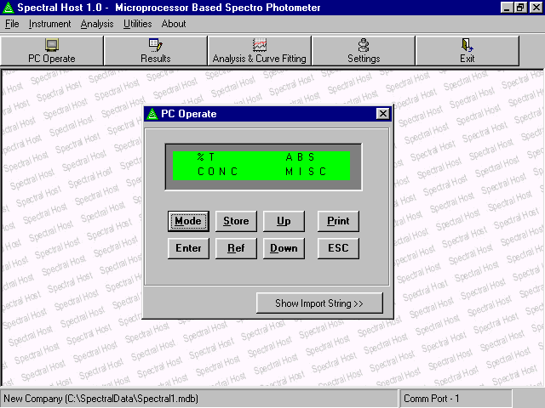

6.0 Result
This module allows importing of results stored in instrument memory and stores them on
PC database along with date and additional remarks. Unlimited results can be stored in
the PC database.

6.1 Importing data from Instrument
To import results click on “Import Result” button. A new window is opened and PC starts
downloading results from instrument. This may take few seconds. The import status is also displayed in progress bar.

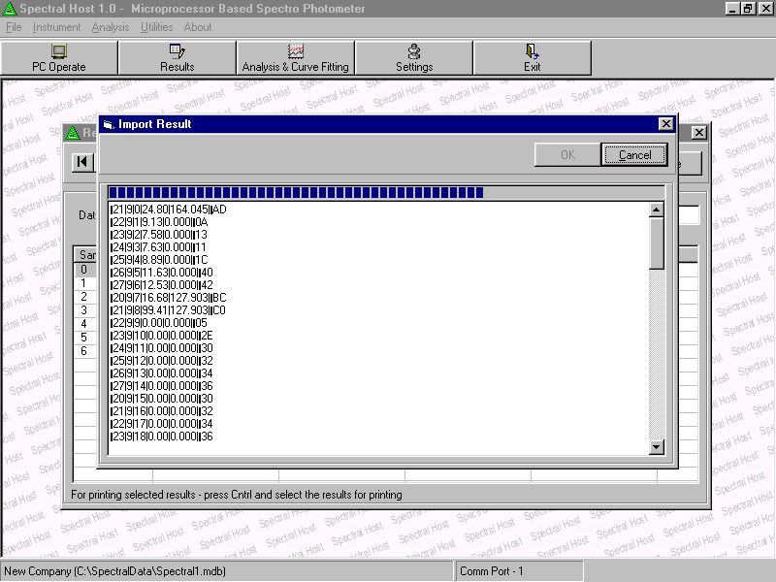

6.2 Converting Imported data to PC Format and Saving it in PC database
After complete data is imported “OK” button is enabled. Press this button to convert
instrument data to PC data format. PC data is displayed in tabular format with – Sample
Number, % Transmission, Absorbance, K-factor and Concentration.

PC imports complete data from Instrument memory. All of this data need not be saved in PC database. User can select records to be saved by placing Tick mark (Check Box) before each record in the available list. Selected data are permanently stored in PC database by clicking “Save” button.

Saved data in PC database is assigned an auto-generated unique Data File No. Unlimited number of data files can be stored. Saved data file can be navigated / searched with the help of four buttons i.e. First, Previous, Next, Last etc.

Additional remarks can be entered and saved along with imported data.
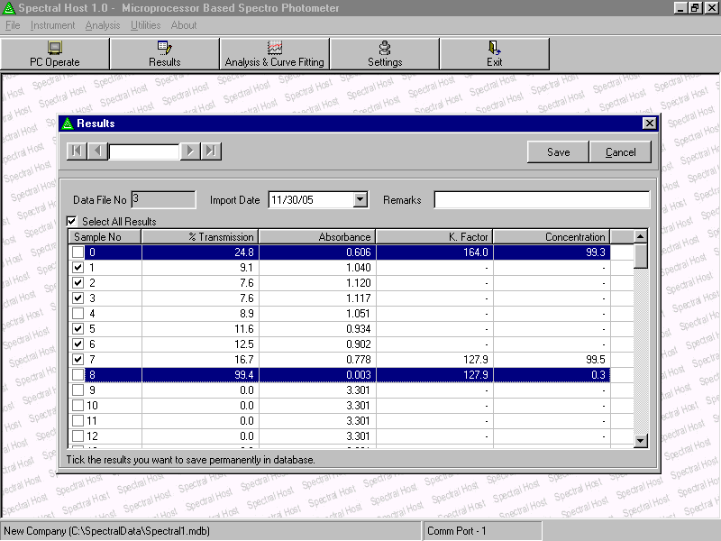

6.3 Printing Result Data
Result data stored in the PC database can be printed by clicking “Print Button”.

7.0 Analysis and Curve Fitting
This module allows user to perform analysis on the results.

7.1 Analysis File
First step to perform analysis is to create an analysis file. This is done by pressing “New”
button. An auto-generated unique File Number identifies each File.

Existing files can be navigated / searched with the help of four buttons i.e. First, Previous, Next and Last.

Existing files can be edited (“Edit” button) and deleted (“Delete Button”) as per requirement.

7.2 Entering data in Analysis File
Data required to perform analysis can be entered in two ways:
a) Selected from the results imported from the instrument. Use the “Select Result Data”
for this this operation.
b) Typed by PC Keyboard.

7.3 Analysis Table and Graph
Software performs three types of analysis a) Point–to-point.
b) Linear Regression
c) Polynomial Regression

For Linear Polynomial Regression at least 3 data points are required.

Each analysis data is displayed in the table. Four graphs i.e. Point-to-Point, Linear
Regression, Polynomial Regression and Combined are drawn in the four tabs.

Tabs

7.4 Calculating Concentration from Absorbance for 3 type of Analysis
Software calculates concentration from Absorbance for each of the three type of analysis. User enters absorbance in a tab and concentration is automatically calculated and
displayed.

7.5 Interpolation Error for 3 type of Analysis
Software calculates and displays interpolation Error for three type of analysis in the respective tab.

7.6 Printing Analysis File Table and Graphs
Analysis File can be printed by clicking “Print” button. 3 Analysis Graphs and Analysis table are printed.

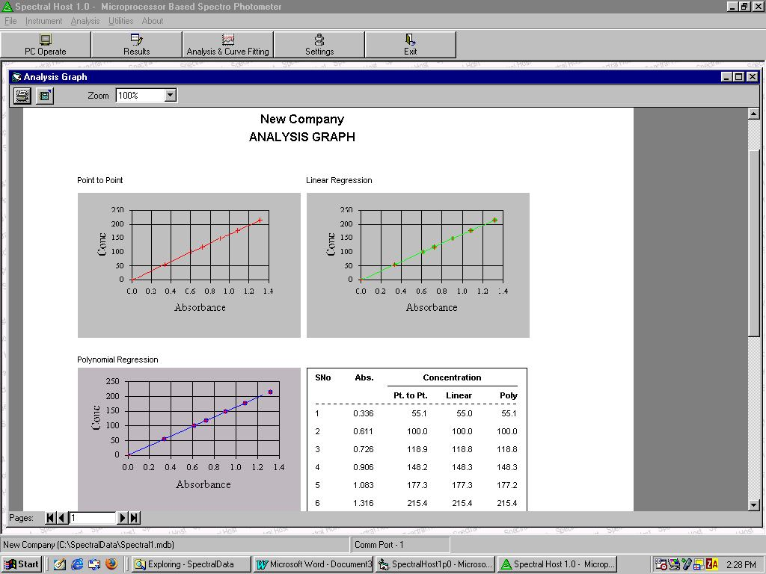

8.0 Settings
This module allows user to set following software parameters:
a) Company Name i.e. Name of the company / organization to be used in the software. b) Communication Port i.e. PC Serial Port Number to which Instrument is connected. c) Print Header / Footer i.e. Header and Footer to be printed on the printouts.
d) Data Formatting Option i.e. decimal places to be used for %T, Absorbance, K-Factor
and Concentration.

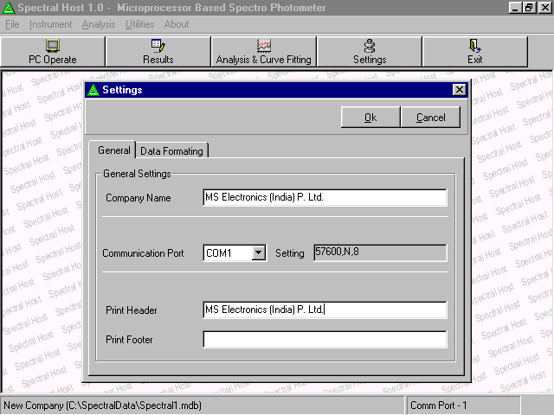
9.0 Utilities
9.1 %Transmission Vs Absorbance Chart
This module allows user to find Absorbance for a range of %Transmission. User enters
Form %T, To %T and Steps and Software calculates Absorbance for this %T range and
the given Step.

This %Transmission Vs Absorbance table can also be printed.

9.2 Calculate Absorbance / %T
This module calculates Absorbance for a given %T and Vice Versa.

